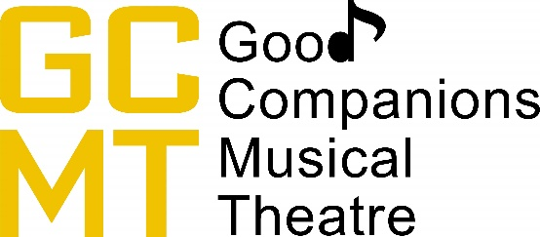

GOOD COMPANIONS MUSICAL THEATRE Privacy and GDPR Policy

The EU General Data Protection Regulation (GDPR) effective from May 2018 gives all EU citizens more rights and protections for their personal data, to minimise the possibility of theft and fraud.
These regulations include provisions for the following areas:
The right to be informed:
Companies must publish a privacy notice, in addition to explaining transparently how they use this personal data.
The right of access:
Individuals will have the right to demand details of any of their data that a company may hold. This information must be provided within one month of request at no charge to the individual.
The right to rectification:
If a person’s data is incorrect or incomplete, he or she has the right to have it corrected. If the company that holds the information has passed any of that information to third parties. The company must inform the third party of the correction and inform the person which third parties have their personal data.
The right to be forgotten:
A person may request the removal of his or her personal data in specific circumstances.
The right to restrict processing:
Under certain circumstances, an individual can block the processing of his or her personal data.
The right to data portability:
A person can access their data for their own use anywhere they prefer.
The right to object:
A person can object to the use of their personal data for most purposes.
​
​

Our core principles regarding user privacy and data protection

· User privacy and data protection are inviolable human rights
· We have a duty of care to people contained within our data
· Data is a liability: it should only be collected and processed when absolutely necessary
· We despise spam in all its forms
· We will never sell, rent or otherwise distribute or make public any personal information

2.0 Relevant legislation
​GOOD COMPANIONS MUSICAL THEATRE complies with the UK Data Protection Act 1988 (DPA)
​​
Contact forms and email links
Should you choose to contact us using the email address on our Contact us page, none of the data that you supply will be stored.

How we store your personal information
GOOD COMPANIONS MUSICAL THEATRE stores the data of its members securely.
We do not store data of customers ourselves, however this is stored by the third party ticketing providers we use and this information will only be accessed by limited members of the company to support with ticket issues, to ensure important information about our current or upcoming production is received or to notify of any unforeseen circumstances or issues that may affect your visit to one of our performances.

Our third party data processors
We use two third parties to process personal data on our behalf. The third parties we use are Ticketsource and Derby Theatre. Please visit their websites to view their policies.
https://www.ticketsource.com/kb/terms-of-use/customer-data-privacy-policy
https://derbytheatre.co.uk/our-policies/privacy-policy/
GOOD COMPANIONS MUSICAL THEATRE will never ask for any sensitive information.
​
Data breaches
We will report any unlawful data breach of our member database or the database(s) of any of our third party data processors to any and all relevant persons and authorities within 72 hours of the breach if it is apparent that personal data stored in an identifiable manner has been stolen.

Changes to our privacy policy
This privacy policy may change from time to time inline with legislation or industry developments. We will not explicitly inform our clients or website users of these changes.
Instead, we recommend that you check this page occasionally for any policy changes. Specific policy changes and updates are mentioned in the change log below.

